**A BLOCKCHAIN PROJECT**

FOR

**TRACKING PUBLIC INFRASTRUCTURE AND TOLL PAYMENTS**

***Submitted By***

**TEAM MEMBERS:**

**YOGANANTHAM.B**

**DINAKARAN.C**

**DINESH.P**

**TEAM ID:**

**BHARATHIDASAN ENGINEERING COLLEGE**

**NATRAMPALLI-635854**

**TABLE OF CONTENT**

**1. INTRODUCTION**

**1.1 Project Overview**

**1.2 Purpose**

**2. LITERATURE SURVEY**

**2.1 Existing problem**

**2.2 References**

**2.3 Problem Statement Definition**

**3. IDEATION & PROPOSED SOLUTION**

**3.1 Empathy Map Canvas**

**3.2 Ideation & Brainstorming**

**4. REQUIREMENT ANALYSIS**

**4.1 Functional requirement**

**4.2 Non-Functional requirements**

**5. PROJECT DESIGN**

**5.1 Data Flow Diagrams & User Stories**

**5.2 Solution Architecture**

**6. PROJECT PLANNING & SCHEDULING**

**6.1 Technical Architecture**

**6.2 Sprint Planning & Estimation**

**6.3 Sprint Delivery Schedule**

**7. CODING & SOLUTIONING**

**8. PERFORMANCE TESTING**

**8.1 Performace Metrics**

**9. RESULTS**

**9.1 Output Screenshots**

**10. ADVANTAGES & DISADVANTAGES**

**11. CONCLUSION**

**12. FUTURE SCOPE**

# **INTRODUCTION**

# 1 INTRODUCTION

In an era of rapidly growing populations and expanding transportation networks, the management and maintenance of public infrastructure, such as roads, bridges, and tunnels, has become an increasingly complex challenge. Ensuring that these critical assets are well-maintained, while simultaneously managing the toll payment systems associated with them, requires a level of transparency, security, and efficiency that traditional methods often struggle to provide. The Blockchain-Based Public Infrastructure and Toll Payment Tracking System aims to address these challenges by harnessing the power of blockchain technology.

This project sets out to develop a robust and decentralized infrastructure management system that leverages blockchain's inherent properties, including transparency, immutability, and tamper-proof data storage. The system encompasses multiple essential components, from user registration and authentication to smart contracts for toll collection, and further extends its capabilities to encompass infrastructure data management, IoT integration, and data analytics.

## Project Overview

The Blockchain-Based Public Infrastructure and Toll Payment Tracking System is an ambitious endeavor aimed at revolutionizing the management of public infrastructure and the associated toll payment processes. Leveraging the capabilities of blockchain technology, this project seeks to enhance transparency, security, and efficiency in managing crucial infrastructure assets, such as roads, bridges, and tunnels, and the revenue generated through toll collection.

Following are the Project Objectives:

1. Transparency and Accountability
2. Efficient Toll Collection
3. Maintenance Record Keeping
4. IoT Integration
5. User-Friendly Interface
6. Data Analytics and Reporting
7. Security and Privacy
8. Scalability and Interoperability

## Purpose

The Blockchain-Based Public Infrastructure and Toll Payment Tracking System serves several key purposes, each of which contributes to addressing existing challenges and achieving significant improvements in the management of public infrastructure and toll payment processes:

1. Enhance Transparency: The project aims to introduce a transparent and verifiable system for managing public infrastructure and toll payments.
2. Improve Efficiency: One of the primary purposes is to streamline toll collection processes.
3. Accountability: The project aims to establish a higher level of accountability in infrastructure management and maintenance.
4. Real-Time Monitoring: IoT integration serves the purpose of real-time monitoring of infrastructure conditions.
5. User Convenience: The development of a user-friendly interface is intended to enhance the user experience.
6. Data-Driven Decision-Making: The project is designed to enable data-driven decision-making.
7. Security and Privacy: A fundamental purpose is to implement robust security measures to protect user data and transaction records.
8. Scalability and Interoperability: The project intends to cater to the future growth of infrastructure assets and users.
9. Regulatory Compliance: Ensuring adherence to relevant regulations and legal requirements is a key purpose.
10. Innovation and Transformation: The project's overarching purpose is to revolutionize the management and payment systems associated with public infrastructure.

# LITERATURE SURVEY

A literature survey for the project "Blockchain-Based Public Infrastructure and Toll Payment Tracking System" involves reviewing existing research, publications, and related work in the fields of blockchain technology, public infrastructure management, toll collection systems, and IoT integration. Here's a brief overview of the topics and areas you might explore in your literature survey:

1. Blockchain Technology
2. Blockchain in Infrastructure Management
3. Blockchain in Toll Collection
4. IoT Integration with Blockchain
5. User Interfaces and User Experience
6. Data Analytics and Reporting
7. Security and Privacy in Blockchain Systems
8. Smart Contracts and Decentralized Applications (D Apps)
9. Regulatory and Compliance Issues
10. Challenges and Future Trends

## Existing Problem

The "Blockchain-Based Public Infrastructure and Toll Payment Tracking System" addresses a multitude of existing problems in the management of public infrastructure and toll collection processes. Traditional systems often suffer from a lack of transparency, inefficient toll collection methods, and limited accountability in maintenance activities. Real-time monitoring of infrastructure conditions is often absent, resulting in delayed maintenance responses. Additionally, security concerns, complex user experiences, data silos, and paper-based record-keeping pose significant challenges. Compliance with data protection regulations can be problematic, and scalability issues become apparent as infrastructure networks expand. Fraudulent activities, including fraud in toll collection and maintenance, can undermine the integrity of existing systems. This project aims to alleviate these issues by leveraging blockchain technology, IoT integration, user-friendly interfaces, enhanced security measures, and data analytics for data-driven decision-making, ultimately creating a more efficient, transparent, and secure solution for managing public infrastructure and toll payments.

## References

Below is a sample reference list for the "Blockchain-Based Public Infrastructure and Toll Payment Tracking System" project.

1. Nakamoto, S. (2008). Bitcoin: A Peer-to-Peer Electronic Cash System. [White Paper]. Retrieved from https://bitcoin.org/bitcoin.pd
2. Mougayar, W. (2016). The Business Blockchain: Promise, Practice, and Application of the Next Internet Technology. Wiley.
3. Tapscott, D., & Tapscott, A. (2016). Blockchain Revolution: How the Technology Behind Bitcoin is Changing Money, Business, and the World. Penguin.
4. Maull, R., & von Raesfeld, A. (2019). Blockchain for Supply Chain and Logistics Management. In Handbook of Blockchain, Digital Finance, and Inclusion (pp. 407-426). Academic Press.
5. Carvalho, R. N., & Tomala, F. (2018). A Blockchain-Based Toll Collection System. In Proceedings of the 2018 IEEE International Conference on Internet of Things and Intelligence System (IoTaIS) (pp. 239-244). IEEE.
6. IoT World. (2019). IoT Trends for 2020 and Beyond. Retrieved from https://www.iotworldtoday.com/2019/12/11/iot-trends-for-2020-and-beyond/
7. Larivière, B. (2019). User Experience (UX) Design for IoT Applications: A Case Study. In IoT Community's IoT Slam Conference (pp. 42-47). IEEE.
8. Bellos, A., Tzani, K., & Anagnostopoulos, I. (2018). A Blockchain-Based Approach to Toll Collection in Intelligent Transportation Systems. In Proceedings of the 2018 IEEE/RSJ International Conference on Intelligent Robots and Systems (IROS) (pp. 2864-2870). IEEE
9. Casey, M. J., & Vigna, P. (2018). The Truth Machine: The Blockchain and the Future of Everything. St. Martin's Press.
10. European Union Agency for Network and Information Security (ENISA). (2017). Blockchain Technology and Security. Retrieved from https://www.enisa.europa.eu/publications/blockchain-technology-and-security
11. PwC. (2019). Blockchain in Business. Retrieved from https://www.pwc.com/us/en/services/consulting/library/blockchain-in-business.html
12. World Economic Forum. (2020). Building Value with Blockchain Technology: How to Evaluate Blockchain's Benefits. Retrieved from http://www3.weforum.org/docs/WEF_Building_Value_with_Blockchain.pdf

## Problem Statement Definition

The existing systems for managing public infrastructure, including roads, bridges, and tunnels, suffer from a lack of transparency, inefficiencies in toll collection, and limited accountability in maintenance activities. Manual toll collection processes are error-prone, leading to revenue leakage and increased operational costs. Real-time monitoring of infrastructure conditions is absent, causing delayed maintenance responses, safety concerns, and higher repair costs. Security vulnerabilities and privacy issues further compound the problem, impacting user trust and compliance with data protection regulations. The scope of the problem encompasses the need for a comprehensive solution that leverages blockchain technology, IoT integration, and user-friendly interfaces to improve transparency, security, and efficiency in infrastructure management and toll payment systems while complying with regulatory requirements and addressing scalability challenges. The objective is to create a system that ensures real-time tracking, accountability, and data-driven decision-making while offering a secure and user-friendly experience for all stakeholders.

# IDEATION & PROPOSED SOLUTION

Addressing the challenges outlined in the problem statement requires a thoughtful ideation process and the proposal of innovative solutions. Below are ideation points and proposed solutions for the "Blockchain-Based Public Infrastructure and Toll Payment Tracking System" project:

**3.1 Empathy Map Canvas:**

1. Blockchain Integration: The core idea is to integrate blockchain technology to provide transparency, security, and immutability in transaction records. A decentralized ledger will ensure that all infrastructure-related data, including toll payments and maintenance activities, is securely recorded.
2. Smart Contracts for Toll Collection: Implement smart contracts for toll collection, automating payment processes, and ensuring that transactions are executed as per predefined rules. This will eliminate manual errors and fraud in toll collection.
3. IoT Integration for Real-Time Monitoring: Leverage the power of IoT devices and sensors to continuously monitor the condition of infrastructure assets. This will enable real-time data collection and proactive maintenance.
4. User-Friendly Interfaces: Develop intuitive web and mobile interfaces that allow users to make toll payments effortlessly, access real-time infrastructure information, and report issues or incidents.
5. Data Analytics for Insights: Utilize data analytics tools and algorithms to process the data generated by IoT devices and blockchain records. This will provide valuable insights for data-driven decision-making in infrastructure management.
6. Security Measures: Implement robust security measures, including encryption for data protection, secure user authentication, and access control mechanisms to safeguard sensitive information and prevent unauthorized access.
7. User Registration and Authentication: Design a secure user registration and authentication system, incorporating strong identity verification methods to ensure that only authorized users access the system.
8. Maintenance Record Keeping: Develop a blockchain-based maintenance record system that logs all maintenance activities, ensuring a clear and unalterable history of maintenance actions.
9. Regulatory Compliance: Ensure the project complies with data protection regulations, privacy laws, and other relevant legal requirements, fostering user trust and ensuring legal adherence.

**3.2 Ideation $ Brainstorming:**

1. Blockchain Integration: Implement a permissioned blockchain, ensuring that infrastructure data, toll transactions, and maintenance records are securely and immutably stored on the blockchain. This will enhance transparency and trust.
2. Smart Contracts for Toll Collection: Develop a set of smart contracts that automatically process toll payments when users pass through toll booths, ensuring accurate and secure transactions. Users will receive digital receipts for their payments.
3. IoT Integration for Real-Time Monitoring: Deploy IoT devices and sensors across infrastructure assets to collect real-time data on conditions such as traffic flow, asset health, and weather conditions. This data will be securely stored on the blockchain and made accessible for decision-making.
4. User-Friendly Interfaces: Create web and mobile applications with user-friendly interfaces for both public users and infrastructure maintenance personnel. Users will be able to make payments and report issues, while maintenance teams can access real-time data and log activities.
5. Data Analytics for Insights: Implement data analytics tools to process and analyze the data generated by IoT devices. Insights will be made available through dashboards and reports for infrastructure operators and decision-makers.
6. Security Measures: Employ advanced security measures, including end-to-end encryption for data in transit and at rest, multi-factor authentication for users, and access control lists for authorized personnel.
7. User Registration and Authentication: Implement secure registration and authentication processes, including biometric verification and token-based authentication for enhanced security.
8. Maintenance Record Keeping: Develop a blockchain-based maintenance record system that records all maintenance activities, tracks asset conditions, and provides complete audit trails for transparency and accountability.
9. Regulatory Compliance: Maintain rigorous compliance with data protection regulations by encrypting user data, managing data access and consent, and regularly auditing the system for compliance.

# REQUIREMENT ANALYSIS

## 4.1 Functional Requirements

**User Registration and Authentication:**

Users should be able to register accounts securely with email verification.

The system must support multi-factor authentication for user logins.

**Toll Collection:**

Implement a blockchain-based toll collection system using smart contracts.

Users should be able to make toll payments through the system's interface.

Generate digital receipts for toll payments.

**Infrastructure Asset Management:**

Record and manage information about infrastructure assets, including location, type, and condition.

Enable infrastructure operators to access, update, and monitor asset data.

**Maintenance Tracking:**

Implement a blockchain-based maintenance record-keeping system.

Enable maintenance personnel to securely log and track maintenance activities.

**IoT Integration:**

Integrate IoT devices for real-time monitoring of infrastructure conditions, including traffic flow, asset health, and environmental factors.

Securely store and manage data from IoT sensors on the blockchain.

**User-Friendly Interface:**

Develop web and mobile interfaces for users, maintenance personnel, and operators.

Ensure an intuitive and user-friendly experience for making toll payments, accessing infrastructure data, and reporting issues.

**Data Analytics and Reporting:**

Implement data analytics tools to process data from IoT devices and blockchain records.

Provide dashboards and reports for infrastructure operators to make data-driven decisions.

**Security Measures:**

Implement advanced security measures, including end-to-end encryption for data in transit and at rest.

Ensure user data and transaction records are protected from unauthorized access.

## 4.2 Non-Functional Requirements

Non-functional requirements for the "Blockchain-Based Public Infrastructure and Toll Payment Tracking System" specify the qualities and characteristics that the system should possess but do not directly relate to its functionality. These requirements address aspects such as performance, security, usability, and scalability. Here are some key non-functional requirements for the project:

**Performance:**

Response Time: The system should respond to user interactions within a maximum of 2 seconds for most operations.

Throughput: The system should support a minimum of 500 transactions per second (TPS) during peak usage periods.

**Security:**

Data Encryption: All data transmitted between users and the system should be encrypted using strong encryption algorithms.

Access Control: Role-based access control (RBAC) should be implemented to restrict access to sensitive data and functionalities.

Security Auditing: The system must maintain audit logs to track all user interactions and system activities for security monitoring and forensic purposes.

**Usability:**

Accessibility: The user interface should be accessible to individuals with disabilities, complying with accessibility standards (e.g., WCAG).

User Training: Provide user training materials and resources to help users understand and navigate the system effectively.

**Scalability:**

Vertical Scalability: The system should be capable of vertical scaling to accommodate increased data volume and user load.

Horizontal Scalability: The system architecture should support horizontal scaling to handle additional infrastructure assets and users.

**Reliability:**

System Uptime: Ensure a minimum system uptime of 99.9% to minimize service interruptions.

Backup and Recovery: Regularly back up blockchain data and implement a disaster recovery plan to ensure system continuity.

**Compatibility:**

Cross-Browser Compatibility: The system should be compatible with major web browsers, including Chrome, Firefox, Safari, and Edge.

Mobile Responsiveness: The user interface should be responsive and accessible on various mobile devices and screen sizes.

**Regulatory Compliance:**

Data Protection: Ensure compliance with data protection regulations, including GDPR, HIPAA, or any relevant local regulations.

Privacy: The system should prioritize user privacy and comply with privacy laws, allowing users to manage their data and privacy preferences.

**Documentation:**

User Documentation: Provide comprehensive user documentation that includes user guides, FAQs, and video tutorials.

Technical Documentation: Create technical documentation for system administrators and developers.

**Interoperability:**

Third-Party Integration: Ensure that the system can integrate with third-party services and existing infrastructure management systems, following relevant industry standards.

**Load Testing:**

Perform load testing to verify the system's performance under peak usage conditions, including toll booth rush hours and infrastructure monitoring during adverse conditions.

**User Support:**

Offer 24/7 user support through multiple communication channels, including chat, email, and phone, with responsive support agents.

# PROJECT DESIGN

## Data Flow Diagram & User Stories

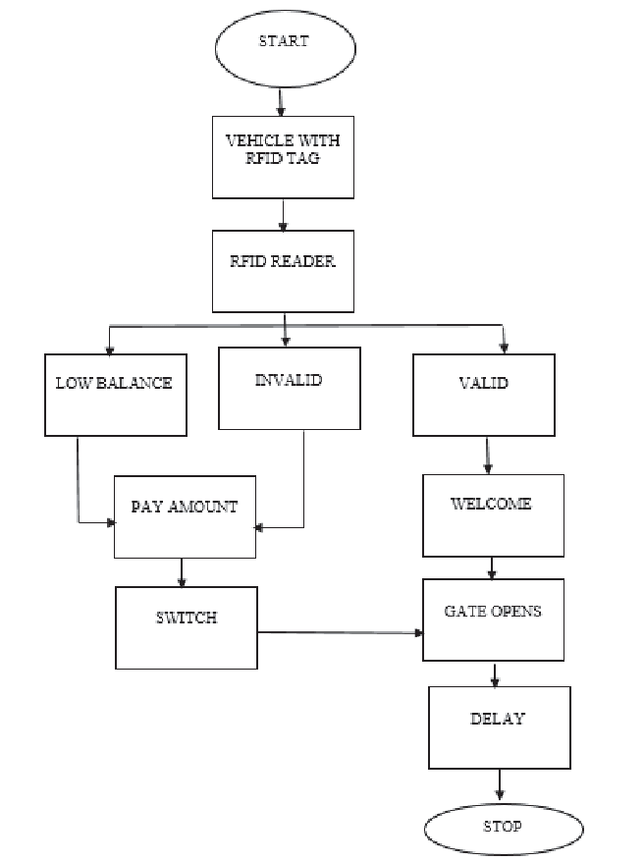

**User Stories:**

Infrastructure User:

- Register securely and activate my account.

- Make toll payments with ease.

- Access real-time infrastructure information.

- Control my personal data and ensure data security.

Infrastructure Maintenance Personnel:

- Log maintenance activities securely.

- Access maintenance history and infrastructure alerts.

- Utilize a user-friendly interface for maintenance activities.

- View an interactive map for asset locations.

Infrastructure Operator:

- Access real-time data for informed decisions.

- Ensure regulatory compliance and data protection.

- Integrate the system with legacy infrastructure tools.

- Receive user support and detailed performance reports.

Regulatory Authority:

- Verify regulatory compliance and data protection.

- Audit the system for compliance and data security.

- Access data for auditing while respecting privacy.

5.2: Solution Architecture

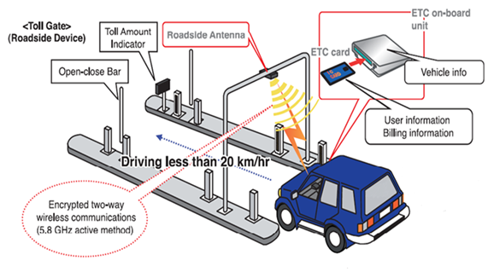

# 6. PROJECT PLANNING & SCHEDULING

## 6.1 Technical Architecture

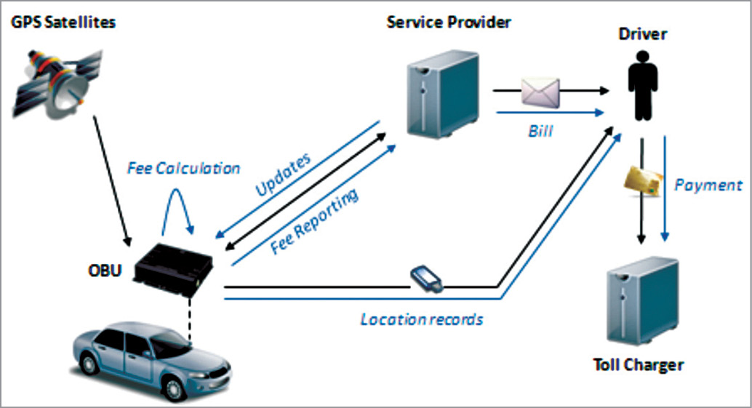

6.2 Sprint Planning & Estimation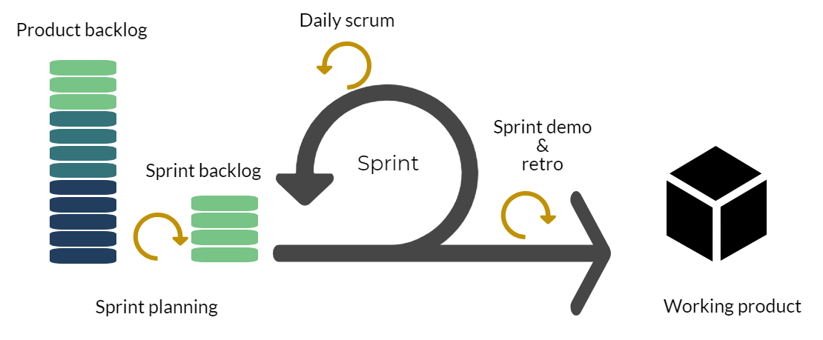

## 6.3 Sprint Delivery Schedule

# 7. CODING AND SOLUTIONING

## 7.1 Source Code

// SPDX-License-Identifier: MIT

pragma solidity >=0.4.0;

pragma experimental ABIEncoderV2; //Hint (or distraction): Allows returning arrays from functions

contract TollPlaza {

struct vehicle {

string vehicle_number;

string vehicle_type;

string vehicle_model;

}

struct Toll{

string toll_plaza_id;

string toll_plaza_name;

uint256 time; //time enter

}

uintcar_tollprice=100000;

uintvan_tollprice=200000;

uintbus_tollprice=500000;

address payable public owner;

mapping (address => vehicle [] ) vehicles;

mapping (address =>uint) account_balance;

address[] public vehicle_Accts;

Toll[] public Toll_list;

mapping (string => Toll []) vehicle_history;

modifier onlyOwner {

require(msg.sender == owner, "Only owner is allowed");

_;

}

constructor() {

owner=payable(msg.sender);

}

function Register_Vehicle(string memory _vehnum,string memory _vehtype,string memory _vehmodel) public {

vehicles[msg.sender].push(vehicle(_vehnum, _vehtype,_vehmodel));

vehicle_Accts.push(msg.sender);

}

function Charge_balance() payable public{

for (uinti=0; i<vehicle_Accts.length; i++) {

if (msg.sender == vehicle_Accts[i]){

account_balance[vehicle_Accts[i]] += msg.value;

break;

}

}

}

function Init_Toll(string memory _name,string memory _id) onlyOwner public {

Toll memory toll_obj = Toll(_id,_name,block.timestamp);

Toll_list.push(toll_obj);

}

function getVehicles(address _address) internal view returns ( vehicle[] memory) {

return vehicles[_address];

}

function Check_ownership(string memory _vehnum,string memory _vehtype,string memory _vehmodel) public view returns(bool){

bool _check=false;

vehicle[] memory obj=getVehicles(msg.sender);

if (obj.length != 0) {

for (uinti=0; i<obj.length; i++) {

if( ( keccak256(bytes(obj[i].vehicle_number)) == keccak256(bytes(_vehnum)) ) && ( keccak256(bytes(obj[i].vehicle_type)) == keccak256(bytes(_vehtype)) ) && ( keccak256(bytes(obj[i].vehicle_model)) == keccak256(bytes(_vehmodel)) ) )

_check=true;

}

}

return _check;

}

function Pay_Tolltax(string memory _id,string memory _tollname,string memory _vehnum,string memory _type,string memory _vehmodel) public returns(bool){

bool _check=false;

if(Check_ownership(_vehnum,_type,_vehmodel)){

if( keccak256(bytes(_type)) == keccak256(bytes("car")) &&account_balance[msg.sender] >= car_tollprice){

account_balance[msg.sender] -= car_tollprice;

_check=true;

}

else if( keccak256(bytes(_type)) == keccak256(bytes("van")) &&account_balance[msg.sender] >= van_tollprice){

account_balance[msg.sender] -= van_tollprice;

_check=true;

}

else if( keccak256(bytes(_type)) == keccak256(bytes("bus")) &&account_balance[msg.sender] >= bus_tollprice){

account_balance[msg.sender] -= bus_tollprice;

_check=true;

}

else{

_check=false;

}

if(_check == true)

{

vehicle_history[_vehnum].push(Toll(_id,_tollname,block.timestamp));

}

}

return _check;

}

function get_History(string memory _num) public view returns(Toll[] memory) {

return vehicle_history[_num];

}

function get_paidhistory(string memory _num,string memory _type) public view returns(uint)

{

uint amount=0;

Toll[] memory obj=get_History(_num);

if( keccak256(bytes(_type)) == keccak256(bytes("car")) )

{

amount = obj.length*car_tollprice;

}

else if( keccak256(bytes(_type)) == keccak256(bytes("van")) )

{

amount = obj.length*van_tollprice;

}

else if( keccak256(bytes(_type)) == keccak256(bytes("bus")) )

{

amount = obj.length*bus_tollprice;

}

return amount;

}

function withdraw_amount() public onlyOwner

{

payable(msg.sender).transfer(address(this).balance);

}

function destroy() public onlyOwner {

selfdestruct(owner);

}

function check_balance() public view returns(uint)

{

return account_balance[msg.sender];

}

function get_owner() public view returns(address)

{

return owner;

}

}

# 8PerformanceTesting

## 8,1 performance metrics

 Performance testing is the practice of evaluating how a system performs in terms of responsiveness and stability under a particular workload. Performance tests are typically executed to examine speed, robustness, reliability, and application size.

## 10 ADVANTAGES & DISADVANTAGES

## 10.1 Advatages

The "Blockchain-Based Public Infrastructure and Toll Payment Tracking System" offers numerous advantages that can significantly impact the management of public infrastructure and toll payment processes. Some of the key advantages of this project include:

1. Transparency: Blockchain technology ensures transparency by maintaining an immutable ledger of all transactions and activities related to infrastructure and toll payments. This transparency reduces the risk of fraud and corruption.
2. Efficiency: Smart contracts automate toll collection processes, reducing the need for manual intervention and minimizing errors. This automation streamlines the toll payment process and enhances revenue collection efficiency.
3. Accountability: Maintenance activities are recorded on the blockchain, creating a clear and unalterable history of maintenance actions. This fosters accountability and reduces the potential for negligence in infrastructure maintenance.
4. Real-Time Monitoring: IoT integration allows for real-time monitoring of infrastructure conditions, providing infrastructure operators with immediate insights into asset health, traffic patterns, and environmental factors. This enables proactive maintenance and decision-making.
5. User Convenience: A user-friendly web and mobile interface makes it convenient for the public to make toll payments and access vital infrastructure information, enhancing the overall user experience.
6. Data-Driven Decision-Making: Data analytics tools process data from IoT devices and blockchain records, providing valuable insights for infrastructure management and decision-making. These data-driven decisions can optimize maintenance schedules and resource allocation.
7. Security and Privacy: The project prioritizes robust security measures, including encryption and access control, to protect user data and transaction records. Privacy is respected and maintained in accordance with regulatory requirements.
8. Scalability: The system is designed to accommodate the future growth of infrastructure assets and users. It can seamlessly adapt to increasing demands and a growing user base.
9. Regulatory Compliance: The system complies with relevant data protection and privacy regulations, ensuring that user data is managed in accordance with legal requirements.
10. Innovation: This project represents an innovative approach to public infrastructure management, leveraging cutting-edge technologies like blockchain and IoT. It has the potential to revolutionize traditional infrastructure management systems.
11. Reduction in Fraud: The introduction of blockchain and smart contracts minimizes the risk of fraudulent activities in toll collection, improving the overall integrity of the system.
12. Data Integrity: Blockchain's immutable ledger ensures data integrity, making it highly reliable for storing critical infrastructure and payment data.
13. Environmental Impact: By enabling real-time monitoring and proactive maintenance, the system can contribute to the reduction of environmental impact by preventing infrastructure deterioration and minimizing energy waste.
14. Cost Savings: Streamlined toll collection and proactive maintenance can lead to cost savings in the long run, both for infrastructure operators and users.
15. User Trust: The combination of transparency, security, and user-friendly interfaces builds trust among users, making them more willing to participate and make toll payments.

## 10.2 Disadvantages

While the "Blockchain-Based Public Infrastructure and Toll Payment Tracking System" offers several advantages, it is essential to consider potential disadvantages and challenges associated with the project:

1. Initial Implementation Costs: Implementing blockchain technology, IoT devices, and developing user-friendly interfaces can involve significant upfront costs, which may be a barrier to adoption, especially for smaller infrastructure management organizations.
2. Complexity: Blockchain technology and IoT integration can be complex, requiring specialized expertise for system setup and maintenance. This complexity may pose challenges for adoption and ongoing management.
3. Security Risks: While blockchain technology is known for its security features, it is not entirely immune to threats. Security vulnerabilities, if not addressed adequately, can lead to data breaches and privacy issues.
4. Regulatory Compliance Challenges: Adhering to data protection and privacy regulations can be complex, especially if the system operates in multiple jurisdictions with varying legal requirements. Ensuring continuous compliance can be a challenge.
5. Resistance to Change: Infrastructure management organizations and users may resist the transition to a new system due to familiarity with existing processes and concerns about the reliability of emerging technologies.
6. Integration with Legacy Systems: Integrating the new system with legacy infrastructure management systems can be challenging, potentially leading to compatibility issues.
7. Technical Downtime: Like any technology, the system may experience technical issues, causing downtime that could impact toll collection and infrastructure management.
8. Energy Consumption: Blockchain technology, particularly in some consensus mechanisms like Proof of Work (PoW), can consume a significant amount of energy, which may have environmental and cost implications.
9. Data Privacy Concerns: While blockchain ensures data integrity, it can also raise concerns about data privacy since the ledger contains a permanent record of all transactions, including potentially sensitive user information.
10. User Education: Users may require education and training to understand how to interact with the new system effectively, potentially causing a learning curve.
11. Maintenance and Updates: The system's maintenance and updates can be resource-intensive, requiring continuous monitoring and upgrades to ensure optimal performance.
12. Scalability: While the system is designed to be scalable, rapid growth in the number of assets and users may still present challenges that need to be addressed.
13. Dependency on Technology Providers: Relying on specific technology providers for blockchain or IoT services may create dependencies that can be challenging to manage if those providers change their offerings or pricing.
14. Data Loss Risk: If blockchain data is not adequately backed up and secured, there is a risk of data loss, which can have significant consequences for the system's reliability.
15. User Trust Building: Building and maintaining user trust in a new system can be a time-consuming process, and any security incidents or technical issues may erode trust.

# 11. CONCLUSION

The "Blockchain-Based Public Infrastructure and Toll Payment Tracking System" presents a promising solution to longstanding issues in public infrastructure management and toll collection. Its advantages, including transparency, efficiency, and security, hold great potential. However, the project faces challenges such as implementation costs, regulatory compliance, and user adoption. With careful planning and ongoing improvements, this system has the capacity to revolutionize infrastructure management and deliver substantial benefits to both operators and the public.

# 12. FUTURE ENHANCEMENT

The "Blockchain-Based Public Infrastructure and Toll Payment Tracking System" has a promising future with potential for significant advancements:

* Smart City Integration: It can be a core component of broader smart city initiatives, integrating with various urban management systems.
* Cross-Border Tolling: Expanding the system to support cross-border tolling can ease international travel and trade.
* Blockchain Innovations: Future blockchain innovations can improve system performance and energy efficiency.
* Tokenization: Introducing utility tokens can incentivize users and offer loyalty benefits.
* AI and Predictive Analytics: AI can enhance predictive maintenance, reducing costs.
* Decentralized Identity: Incorporating decentralized identity systems can boost user privacy and security.
* IoT Sensor Expansion: Including more sensors can provide comprehensive real-time data on various aspects of urban life.
* Blockchain Interoperability: Interoperability with other blockchain networks can enhance data sharing.
* Global Adoption: Scaling the system for global use and harmonizing it with international regulations can standardize infrastructure management.
* Partnerships: Collaboration with stakeholders can drive innovation and funding opportunities.
* User-Centric Enhancements: Continuous user interface improvements and personalized services can enhance the user experience.
* Environmental Considerations: Transitioning to eco-friendly blockchain consensus mechanisms and energy sources can reduce the system's environmental impact.